Pool Parties!!!
A pool party can be done by active, associate and non-members!!!
Rental requires a rental agreement as well as a $30 non-refundable deposit made preferable 5 days before the party!
Active Members $40/hr
Associate Members $90/hr
Non-Members $125/hr
Concession is also available upon request.
If you party exceeds 50 people an additional lifeguard is required for a fee of $12/hr.
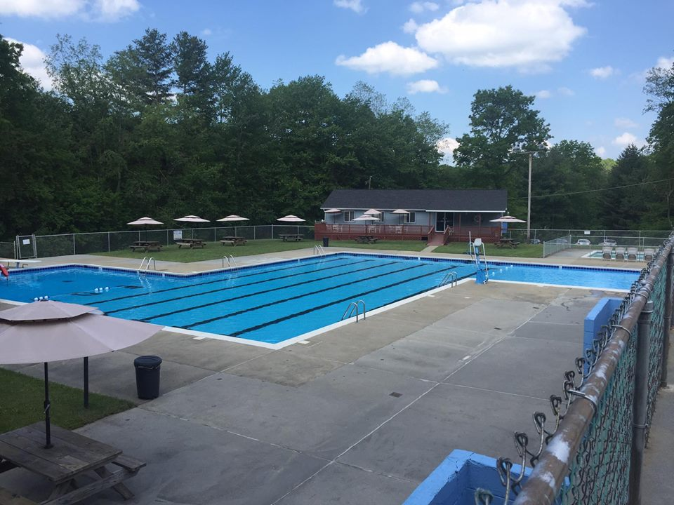
Pool Parties!!!
A pool party can be done by active, associate and non-members!!!
Rental requires a rental agreement as well as a $30 non-refundable deposit made preferable 5 days before the party!
Active Members $40/hr
Associate Members $90/hr
Non-Members $125/hr
Concession is also available upon request.
If you party exceeds 50 people an additional lifeguard is required for a fee of $12/hr.

